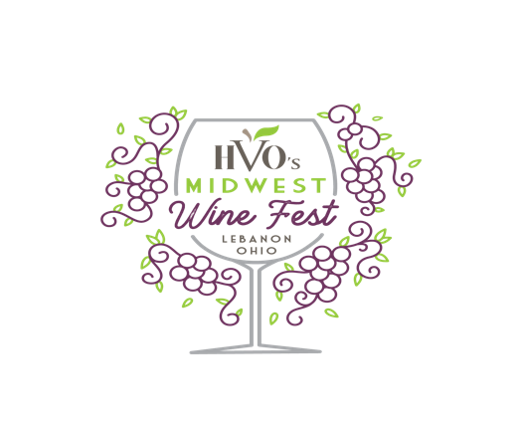
WHAT IS THE HVO Wine Fest: It is a summer wine tastings event hosted in an open-air setting in the long bard at Hidden Valley Orchards, in Lebanon Ohio. A portion of the proceeds will be donated to the Big Brothers Big Sisters.
DATE: May 27, 2023 4pm-7pm
WHO IS ELIGIBLE TO PARTICIPATE: A booth participant is a Licensed Vintner, supplier and/or distributor, whose wines are currently distributed in Ohio. Wine Booths must pay a booth fee of $300.00, donate wine or a gift basket to be raffled off for the Big Brothers Big Sisters, a company representative or special event personal must be present for the entire event. HVO is not responsible for lost or damaged products. Up to (5) wine offerings only.
REGISTER: Booths will reserve quickly. Register Today. We will begin promoting the event by April 1st via our social media and want to include all registration vendors. You will be asked to share the event on your social media platforms to help increase event exposure and attendance.
REGISTRATION FEE: $300 Registration fees are non-refundable.
REGISTRATION LINK: https://www.hiddenvalleyorchards.com/wine-fest-vendors
BOOTH DETAILS: The space is 10’ x 10’area and includes a skirted 6-foot table, ice and dump buckets. Any additional decorations would be up to the vendor. This event is open-air and will be held in the long barn.
TIME/DURATION OF THE EVENT: Event Opens 4:00PM-7:00PM; You will be assigned a check in time after your registration is complete. Your company representative or special event personal must be onsite throughout the entire duration of the event.
HOW MUCH WINE SHOULD WE PREPARE TO BRING: HVO recommends 3 bottles of each product you want to promote. HVO will purchase 3 bottles of each varietal of wine. “Premium Wines” is considered by cost of the bottle ($29.00 Retail or higher) HVO will purchase 2 bottles of “Premium Wine” of each varietal of wine. HVO request that only one bottle of each varietal be open at a time to eliminate waste.
HOW THIS IS GOING TO WORK/PROCESS FOR GUESTS: Guests will register for the wine tasting event on the Hidden Valley Orchards website. Their registration qualifies them for a tasting glass, 10 total tickets, 4 tasting tickets for “Premium Wine” premium wine is considered by cost of the bottle ($29.00 Retail or higher). 6 tickets for all other wines. Premium wine tickets can be used at any booth. All pours are 2 oz. pours. All guests will have their identification checked and provided wristbands upon entering the gated, open-air venue space. HVO will be presenting food stations for guests to purchase hand-held food items.
WHO TO CONTACT WITH QUESTIONS: Nikki Markoff via email only. nikki@hiddenvalleyorchards.com

